CS 340 Animal Shelter CRUD README

About the Project/Project Title
This project is a Python module implementing the Create and Read operations of a CRUD interface for the Austin Animal Center’s (AAC) animal shelter dataset in MongoDB. The project uses a PyMongo-based AnimalShelter class so that records can be inserted, queried, modified, and removed without writing MongoDB queries directly.
Project’s Purpose
The purpose of this project is to build the data-access foundation for a larger animal shelter application. The AnimalShelter class acts as the single point of contact between the application and the MongoDB aac database. An authenticated connection is opened and allows the user to use the create(), read(), update(), and delete() methods so that every part of the applications works with simple Python dictionaries rather than database commands.

Motivation
Centralizing the database logic in one class keeps MongoDB syntax out of every script that needs the shelter data, keeps credentials out of the module’s source code, and gives future interfaces a reusable and secure way to create and retrieve records.

Getting Started
Database and Authentication:
A MongoDB instance was set up locally with an aac database and animals collection. The database was populated using the Austin Animal Center Shelter Outcomes dataset. A dedicated user, aacuser, with read/write access limited to the aac database is created within the admin database. This allows for the user to login using the created credentials and the user will only contain read/write access for the aac database.
Building the Create and Read Methods:
The create() method takes in key/value pairs as the argument and assigns each new record a rec_num using a helper method that finds the latest record number and adds one, then inserts the record using insert_one(), returning True or False based on MongoDB’s acknowledgement.
The read() method runs find(query), where query contains a key/value lookup pair, and returns all matching records from oldest to latest.
Building the Update Method:
The update() method takes two dictionaries: a query that selects which records to change based on a key/value pair, and new_data that holds the fields and their new values. It runs update_many() with MongoDB’s $set operator so that only the listed fields are changed and the rest are left alone, then returns the number of records modified. Both arguments are required to update records, if either are missing than the update will not occur. Because update_many() changes every matching record, the query should use a unique field such as animal_id or rec_num when a specific record needs to be updated.
Building the Delete Method:
The delete() method takes a query dictionary, runs delete_many(), and returns the number of records deleted. It checks if data: before running, which rejects both None and an empty dictionary {}. An empty query would match with every record, resulting in the deletion of every record, so the if data: check is crucial.
Reproducing the Project
The steps below reproduce the project from an empty environment. All work was done within a Codio workspace with MongoDB running and Jupyter Notebook. You will need the aac_shelter_outcomes.csv file which will make up the database.
Step 1: Importing the dataset
First you must identify and move to the folder containing the aac_shelter_outcomes.csv file and load it into the aac database using the command:
mongoimport --db aac --collection animals --headerline --type csv ./aac_shelter_outcomes.csv
Step 2: Create a user
Open mongosh and switch to the admin database. Then create a user with read/write access for the acc database only:
mongosh
use admin
db.create({use: “aacuser”, pwd: “<password>”, roles: [{role: “readWrite”, db: “aac”}])
Step 3: Verify authentication
Log in as the newly created aacuser and confirm the roles with db.runCommand({connectionStatus:1})
mongosh -u “aacuser” -p --authenticationDatabase “admin”
Step 4: Write the CRUD module
Create CRUD_Python_Module.py containing the AnimalShelter class. The constructor takes the username and password as parameters and connects to the aac database and animals collection on localhost: 27017. The class will be used to define the create(), read(),update(), and delete() methods.
Step 5: Write and run the test script
Create a .ipynb file and open it in Jupyter Notebook. The script imports AnimalShelter and creates an instance with the accuser credentials created in step 2. The operations will then run in order: create a new record, read it back, update the record, and then delete it. Run the script to ensure functionality of CRUD operations.
Step 6: Confirm results
After running the script, the console should print that the creation was successful, print the queried result, print the number of modified records, and print the number of deleted records.
Roadblocks and Design Decisions
- Authentication initially failed because I was attempting to log into the wrong database. Despite the user “aacuser” having read and write access to the aac database, you can’t log into that database using that user. The “accuser” user was created in the admin database and must be logged in through that database using --authenticationDatabase “admin”.
- Credentials stay out of the module. Instead of writing the credentials in the source file, they are passed into AnimalShelter() by calling the script instead.
- Each record contains a rec_num which is unique from the object id that is generated with the creation of every record. A supporting helper method get_next_rec_num() was created to find the highest value and adds one.

Installation
Tools used:
- Python 3.x – The language the project is written in.
- MongoDB – Stores shelter records in a flexible, document-based schema.
- PyMongo – The official MongoDB driver for Python.
- bson – Installed with PyMongo.
Step 1:
Install Python 3.x and MongoDB.
Step 2:
Install the MongoDB driver for Python: pip install pymongo
Step 3:
Copy CRUD_Python_Module.py into your project and import the AnimalShelter class.

Usage

Code Example
from CRUD_Python_Module import AnimalShelter
shelter = AnimalShelter(“<username>”, “<password>”)
# Create a new animal record
shelter.create({“name”: “Gerald”, “animal_type”: “Dog”, “breed”: “Corgi”})
# Read all animal type records
query = {“animal_type”: “Dog”}
results = shelter.read(query)
# Update the breed of every record matching the query
# updated_results hold the number of modified records
updated_results = shelter.update({“name”: “Gerald}”, {“breed”: “Pitbull”})
# Delete every record matching the query
# deleted_results hold the number of deleted records
deleted_results = shelter.delete({“name”: “Gerald”})

Tests
The short test script from the code example above connects with valid credentials, calls create() with a sample record and then calls read() with a matching query that confirms the record is returned. The update() method queries the database for all records containing the name “Gerald” and changes their breed to “Pitbull”. The number of records modified should be printed. The delete() method searches for all records containing the name “Gerald” and deletes them from the database. The number of deleted records should be outputted.

Screenshots
MongoDB Import Execution
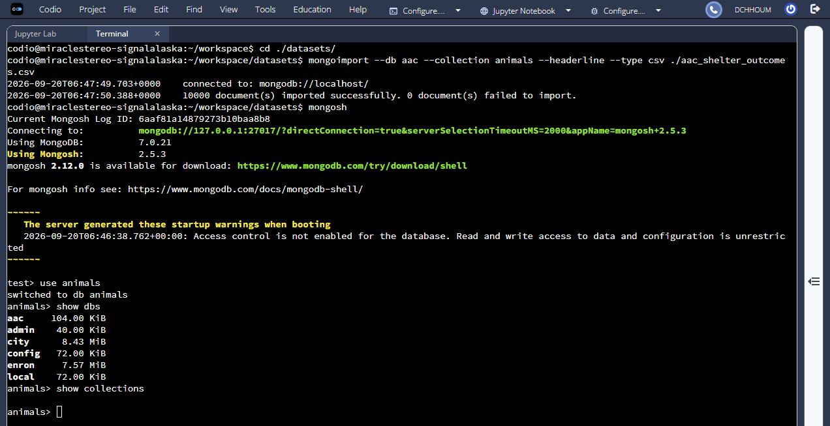
User Creation and Authentication Execution
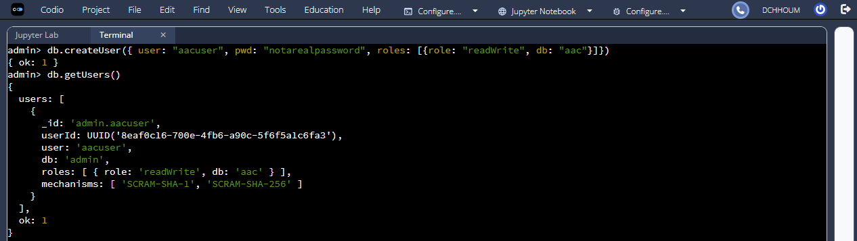
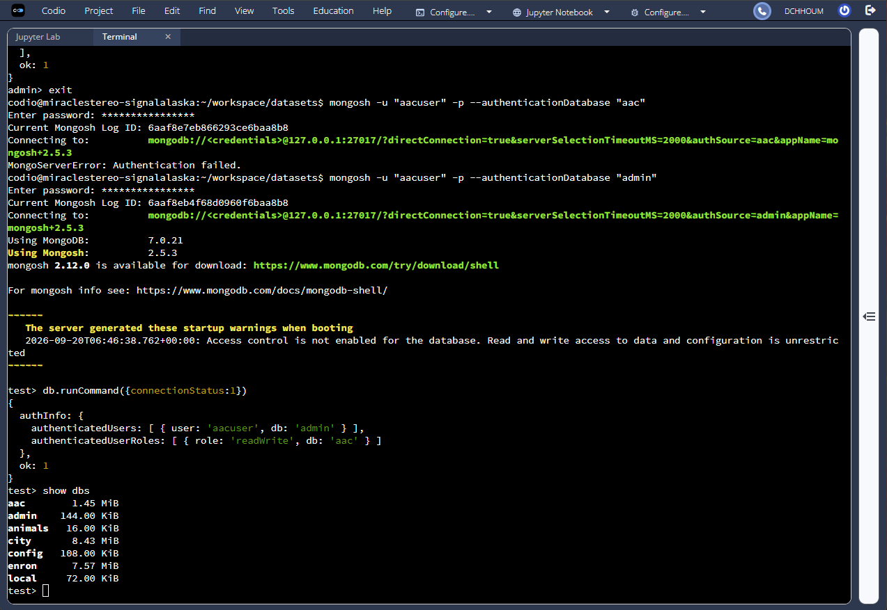
CRUD Functionality Test Execution
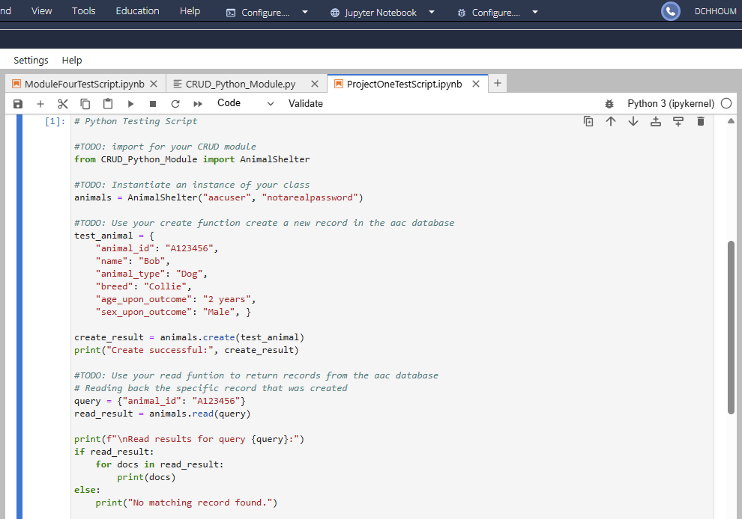
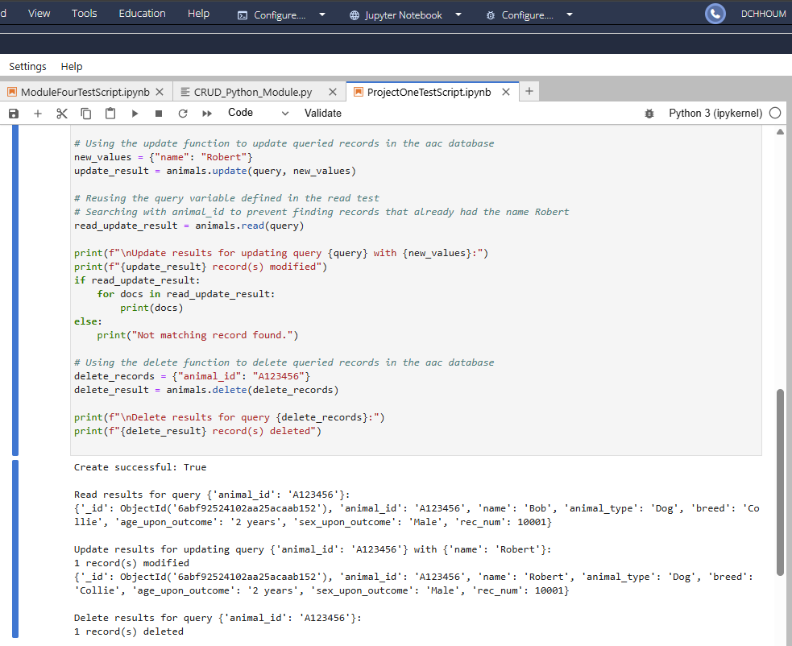

Contact
Donavin Chhoum

